Name

Email

Mobile phone

Postal Address

Date of photographs

Time of photographs | Start: | Finish:

Please select packages required
Service | Requested | Cost | Time period
Wedding Photography | ◻ | $200 | 2hr booking.
Rainforest Mist | ◻ | $150 per 30 minutes | Time from: | Time to:
After-hours Fee | ◻ | $100 per hour | Period of booking after 5 pm, minimum charge $200
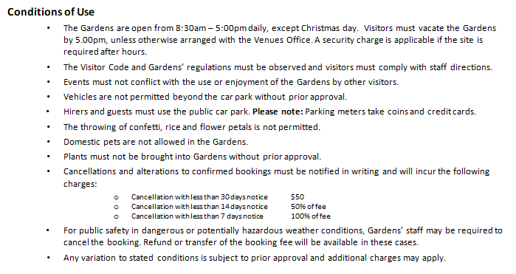
Booking Confirmation and Payment
Full payment and the completed booking form are required to confirm a booking.
Payment of  $ (includes GST) | ◻ Visa  ◻ Master Card
Card number: _ _ _ _ _ _ _ _ _ _ _ _ _ _ _ _
Name of cardholder: i | Expiry: _ _ / _ _
I agree to abide by the conditions of use.

Signature of hirer: Date:

